The Sun and Nuclear Fusion

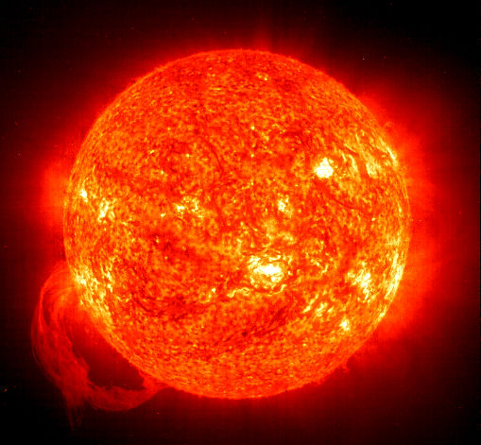
Stars “burn” from a process called Nuclear Fusion.
The following are the steps in nuclear process that take hydrogen gas and ultimately make energy.

Step 1. Two protons combine to form a deuterium (Deuterium is a hydrogen atom with one neutron), a positron (a positron is similar to electron, but with a positive charge) and a neutrino
Step 2. A proton and a deuterium atom combine to form a helium-3 atom (a helium-3 atom has two protons and one neutron) and a gamma ray.
Step 3. Two helium-3 atoms combine to form a helium-4 (two protons and two neutrons) and two protons.

Now, the helium-4 atoms are less massive than the two hydrogen atoms that started the process. The difference in mass was converted to energy given by Einstein's theory of relativity (E=mc2).
"The Sun, with all the planets revolving around it, and depending on it, can still ripen a bunch of grapes as though it had nothing else in the Universe to do."
- Galileo
Source: https://www.wwu.edu/astro101/
So where does the light and energy come from?
THE GAMMA RAY!

Consider the following.
- The high-energy gamma ray photons produced at the core is then transported to the space by the process of radiative diffusion and convection and then again by radiation.
- During the energy transport mechanisms, the entirety gamma rays in the core are converted into visible, ultraviolet light, X-rays, visible light, infrared, microwaves and radio photons producing a continuous (thermal) spectrum.
- Thus it is this energy produced by the nuclear fusion at the sun's core that strikes the earth, provides warmth to the planet and drives our weather and provides energy for life.
- Since Sun has got a vast amount of hydrogen element, it will continue to produce energy for next billion numbers of years and is therefore an inexhaustible source of energy for us.

Activity
Using the grayscale table below, assign colors to each of the particles to show the three step process that turns hydrogen in to helium. Refer to the directions above to correctly label each particle.

Key:
Proton | Neutrino | He-3 |  | He - 4
Deuterium | Positron | Gamma Ray
+  + |  |  | 
Two protons fuse to form one deuterium atom plus one positron and one neutrino |  |  | The deuterium produced fuses with another proton to form He-3 and a gamma ray is given off. This gamma ray is the light possessing photon |  | Two He-3 atoms fuse and form He-4 and two protons.

Remember: The gamma particle is the particle that is responsible for light and energy we see. Using a highlighter, mark this specific particle on the chart.

Questions

- In the third bullet of the “Consider the Following” section, the author states, “…it is this energy produced by the nuclear fusion at the sun's core that strikes the earth.” Explain in which step the energy is released from the Sun and eventually radiates to Earth.

- The last bullet point of the “Consider the Following” section makes the claim that the sun will “produce energy for next billion numbers of years“ but that it is also “… an inexhaustible source of energy.” How can the authors claim that the Sun is both a limited source (billions of years) AND also produce unlimited (inexhaustible) energy?

